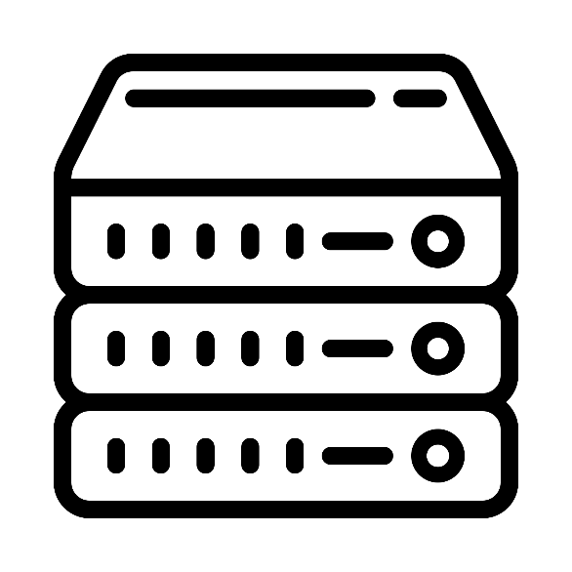

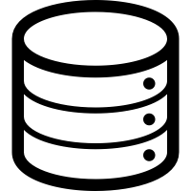

**Displays changes**

**Data**

**Controller**

**1) Requests data from DB**

**2) Forwards updates to FE**

**3) Checks for crashes and displays relevant message**

**Front End**

**Returns data or null**